**MINISTRY OF EDUCATION AND TRAINING**

**FPT UNIVERSITY**

Capstone Project Document

The Roll System using Mobile Device

|  |  |
| --- | --- |
| **Group 1** | |
| **Group member** | Pham Huy Hoang – Team Leader – 60740  Nguyen Thanh Binh – Team Member - 60321  Nguyen Quoc Huy – Team Member - 60551  Do Minh Dat – Team Member - 60545 |
| **Supervisor** | Mr. Kieu Trong Khanh |
| **Ext. Supervisor** | N/A |
| **Capstone Project code** | RSM |

-Ho Chi Minh City, 09/2013-

*This page is intentionally left blank*

***ACKNOWLEDGEMENTS***

We wish to thank various people for their contribution to this project: Our teachers for their advices and participant in the final review, our friend for the valuable technical support.

Special thanks should be given to Mr.Kiều Trọng Khánh, our research supervisor for his professional guidance and the useful, constructive recommendations throughout the course of this project.

# Table of Contents

**Table of Contents 4**

**List of Tables 5**

**List of Figures 6**

Definitions, Acronyms, and Abbreviations 7

A. Software User’s Manual 8

1. Installation Guide 8

1.1 Setting up environment at server site 8

1.2 Deployment at server side 8

1.3 Setting up the environment at client side 14

2. User Guide 16

2.1 Login 16

2.2 Admin – Add Image for student 16

2.3 Staff – Create Roll Call 17

2.4 Instructor – Check Attendance (Mobile) 21

2.5 Instructor – Check Report 24

3. User Notice 26

3.1 Image Data Notice 26

3.2 Position & Angle Notice 27

3.3 Other Notice 28

# List of Tables

Table 1: Login Step 16

Table 2: View Student Image Step 16

Table 3: Upload Image Step 17

Table 4: Select Student Image Step 17

Table 5: View Roll Call List Step 18

Table 6: Create Roll Call Step 19

Table 7: Change Student List Step 20

Table 8: Change Schedule Step 20

Table 9: Login Step 21

Table 10: View Roll Call List Step 21

Table 11: Check Attendance Step 22

Table 12: View Roll Call Detail Step 22

Table 13: Take Attendance Manual Step 23

Table 14: View Teaching Roll Call Step 24

Table 15: View Roll Call Report Step 24

# List of Figures

Figure 1: Prepare deployment package 9

Figure 2: Deploy database – 1 9

Figure 3: Deploy database - 2 10

Figure 4: Deploy database - 3 10

Figure 5: Configure Server before deploy – 1 10

Figure 6: Configure Server before deploy – 2 11

Figure 7: Configure Server before deploy - 3 11

Figure 8: Deploy web application on server - 1 12

Figure 9: Deploy web application on server – 2 12

Figure 10: Deploy web application on server – 3 12

Figure 11: Deploy web application on server – 4 13

Figure 12: Deploy web application on server – 5 13

Figure 13: Change Settings 14

Figure 14: Download app 15

Figure 15: Install App 15

Figure 16: Login Page 16

Figure 17: Student List Page 16

Figure 18: Upload Image Page 17

Figure 19: Select Student Image Page 17

Figure 20: Roll Call List Page 18

Figure 21: Create Roll Call Page 19

Figure 22: Roll Call Student List Page 20

Figure 23: Change Schedule Page 20

Figure 24: Login Screen 21

Figure 25: Roll Call List Screen 21

Figure 26: Camera Screen 22

Figure 27: Roll Call Detail Screen 22

Figure 28: Take Attendance Screen 23

Figure 29: Instructor Home Page 24

Figure 30: Roll Call Detail Page 24

Figure 31: Report - Sheet 1 25

Figure 32: Report - Sheet 2 25

# Definitions, Acronyms, and Abbreviations

|  |  |
| --- | --- |
| RSM | Roll System Mobile |
| Face Detection | **Face detection** is a computer technology that determines the locations and sizes of human faces in arbitrary (digital) images. It detects facial features and ignores anything else, such as buildings, trees and bodies.  <http://en.wikipedia.org/wiki/Face_detection> |
| Face Recognition | Face recognition is the task of identifying an already detected object as a **KNOWN or UNKNOWN face**, and in more advanced cases, **telling EXACTLY WHO'S face it is**! |
| Student List for final exam | A list contains all the students who can take part in the final exam of a roll call (Student with **absent rate > 20%** can’t take part in final exam). |

# Software User’s Manual

## Installation Guide

### Setting up environment at server site

The following software must be installed into the server machine:

#### Hardware requirements

Personal computers for developing with the minimum configuration:

* CPU Core 2 Duo 2.0GHz.
* 4GB of RAM.
* 300GB of hard disk.
* Wifi Internet (> 2Mbps).

#### Software requirements

* Web Server: Internet Information System – IIS 7.5
* Microsoft Windows 7: operating system and platform for development
* SQL Server 2008 R2: used to create and manage the database for web application
* Other library:
* EmguCV x86 2.4.2

(<http://sourceforge.net/projects/emgucv/files/emgucv/2.4.2/libemgucv-windows-x86-gpu-2.4.2.1777.exe/download>)

* Microsoft Visual C++ 2010 SP1 Redistributable Package (x86)

(<http://www.microsoft.com/en-us/download/details.aspx?id=8328>)

#### Mobile Requirement

* Android 4.0 or above
* Camera 3.0 Megapixed or above

### Deployment at server side

#### Prepare deployment package

* Extract the deployment package to a folder on the server.
* For example: D:\Capstone Project

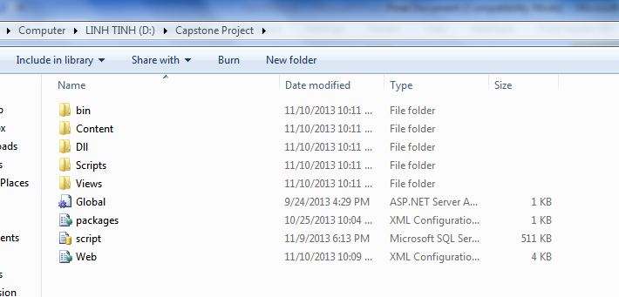

**Figure 1: Prepare deployment package**

#### Deploy database

* Open Microsoft SQL Server Management Studio
* Open the script.sql file

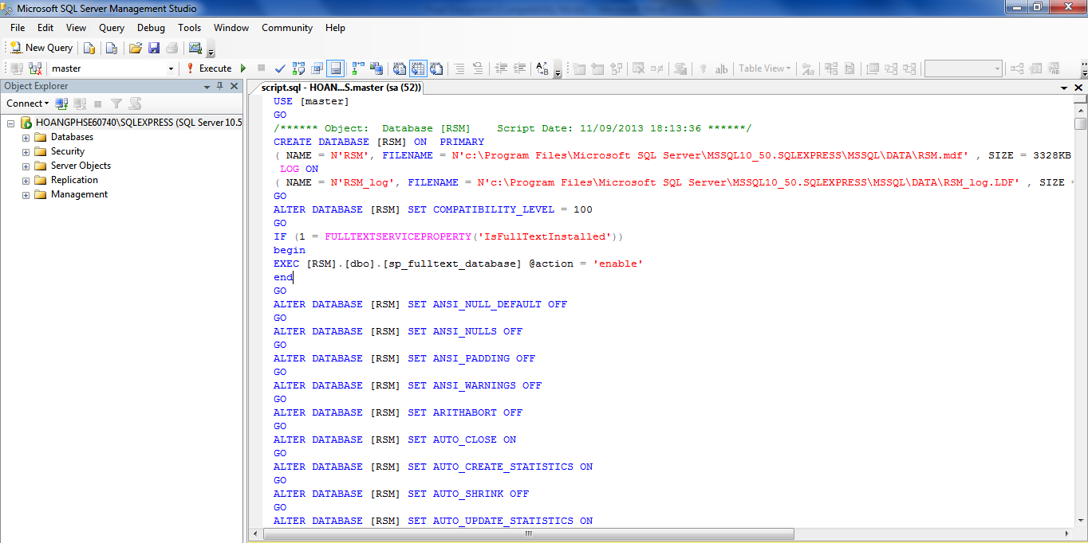

**Figure 2: Deploy database – 1**

**Figure 3: Deploy database - 2**

* Execute the script to finish the process

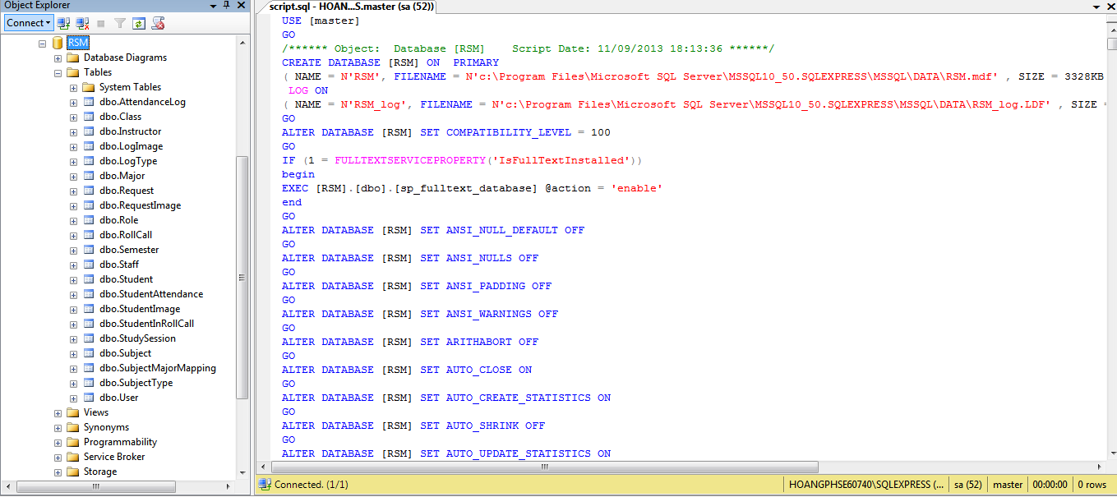

**Figure 4: Deploy database - 3**

#### Configure Server before deploy

* Open the Internet Information System Manager
* Change the .NET Framework version to 4.0
* Click the Application Pool

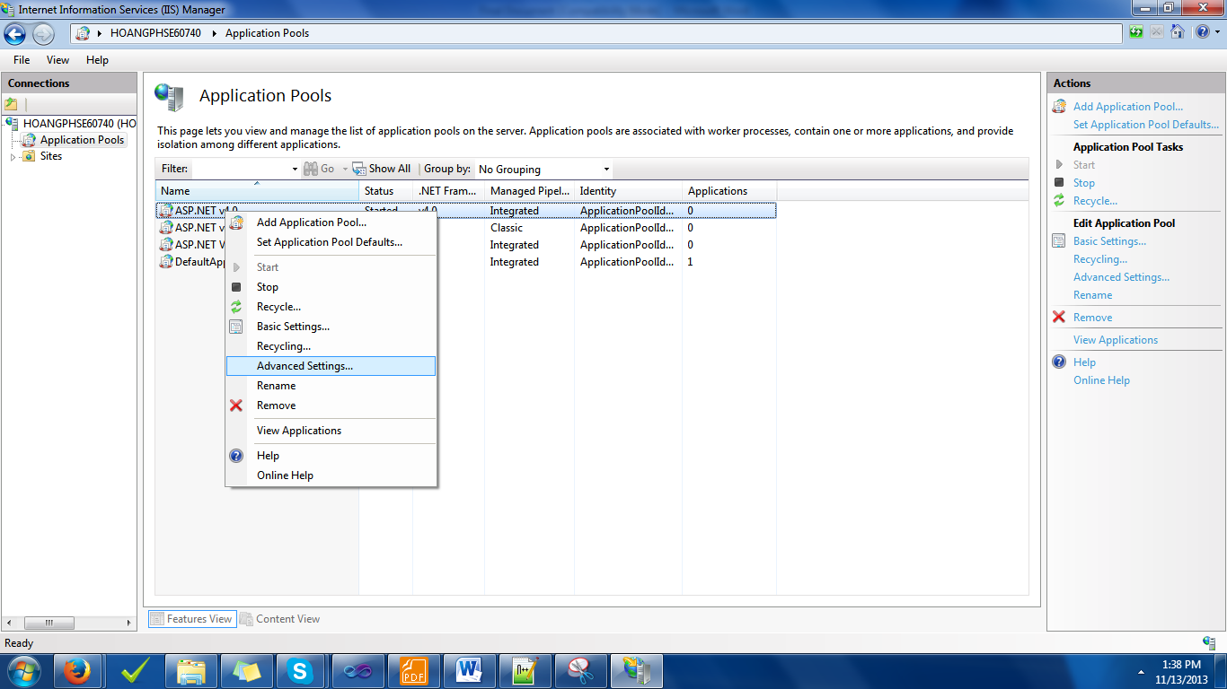

**Figure 5: Configure Server before deploy – 1**

**Figure 6: Configure Server before deploy – 2**

* Right click the ASP.NET 4.0 Pool, select “Advance Settings”.
* Set “Enable 32-bit Applications” to True.

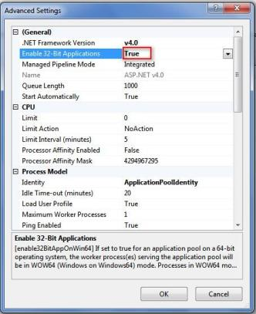

**Figure 7: Configure Server before deploy - 3**

#### Deploy web application on server

* Change the connection string in Web.config
* Replace the “integrated security” with your own username and password

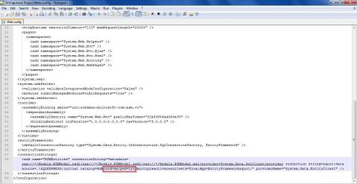

**Figure 8: Deploy web application on server - 1**

**Figure 9: Deploy web application on server – 2**

* Right click as Sites. Choose “Add Web Site”.

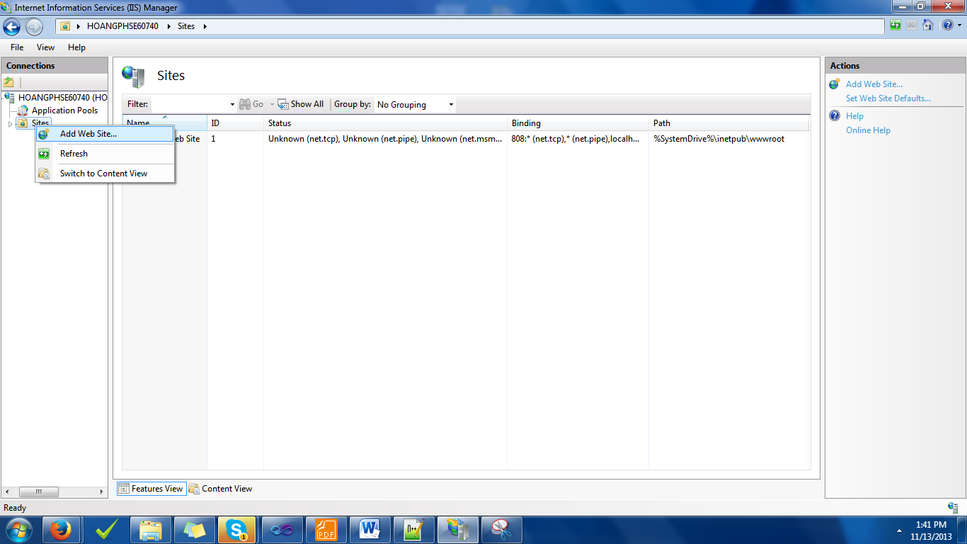

**Figure 10: Deploy web application on server – 3**

* Enter site name. Choose Application Pool as ASP.NET 4.0
* Select the path as the folder in step 1. Enter port other than 80.

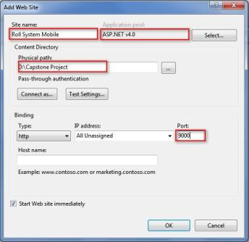

**Figure 11: Deploy web application on server – 4**

* Press ok to finish the process

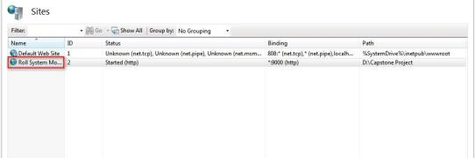

**Figure 12: Deploy web application on server – 5**

### Setting up the environment at client side

#### Setting up for computer

* The client devices need to have one of the following browsers to access the website:
* Google Chrome.
* Firefox.

#### Setting up for Android devices

* Change setting to install unknown source apk.
* Connect to the same network as the server

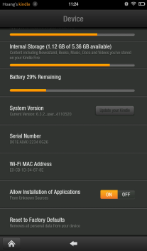

**Figure 13: Change Settings**

* Use browser and goto address 192.168.218.1:2987, download the apk file.

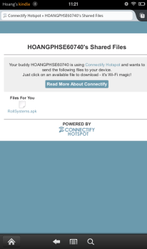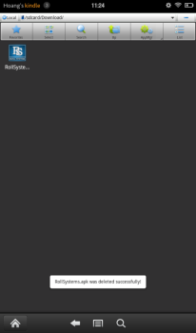

**Figure 14: Download app**

Click Install to install the app.

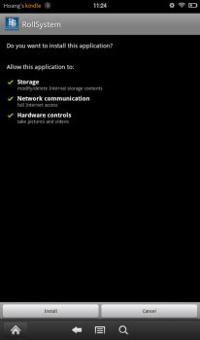

**Figure 15: Install App**

## User Guide

The user guide is based on the normal workflow of the system

### Login

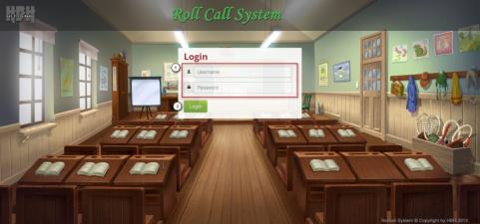

**Figure 16: Login Page**

|  |  |
| --- | --- |
| **Step** | **Description** |
| 1 | Fill Username and Password  (Sample admin account:  Username: admin1. Password: 123456) |
| 2 | Click button Login |

**Table 1: Login Step**

### Admin – Add Image for student

#### View Student Image

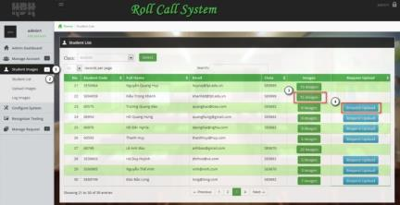

**Figure 17: Student List Page**

|  |  |
| --- | --- |
| **Step** | **Description** |
| 1 | Click Tab Student Images |
| 2 | Click link Student List |
| 3 | Click button “…. Images” to view, add more image for students |
| 4 | Click button “Request Upload” to send image upload request to students |

**Table 2: View Student Image Step**

#### Upload Image

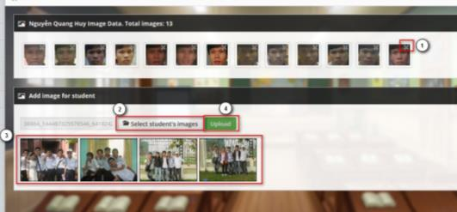

**Figure 18: Upload Image Page**

|  |  |
| --- | --- |
| **Step** | **Description** |
| 1 | Click to delete an image |
| 2 | Click button “Select student’s images” to select image for upload |
| 3 | Display thumbnail of selected image |
| 4 | Click button “Upload” to upload the selected images |

**Table 3: Upload Image Step**

#### Select Student Image

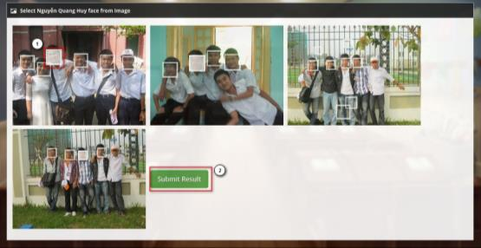

**Figure 19: Select Student Image Page**

|  |  |
| --- | --- |
| **Step** | **Description** |
| 1 | Click to select the face of students |
| 2 | Click button “Submit result” to save the selected face |

**Table 4: Select Student Image Step**

### Staff – Create Roll Call

#### View Roll Call List

#### index.png

#### Figure 20: Roll Call List Page

|  |  |
| --- | --- |
| **Step** | **Description** |
| 1 | Click on link “Create new roll call” to create a roll call. |
| 2 | Select the semester, duration date includes roll calls you want to show in list. |
| 3 | Click on “Select” button to show result of step 2. |
| 4 | Click to report attendance of roll call. |
| 5 | Click to report attendance summary of roll call. |
| 6 | Click to search information you find. |
| 7 | Clink on link “Check Attendance” to check attendance for roll call. |
| 8 | Click on link “Change” to change schedule of roll call. The old roll call will not have this link. |
| 11 | Click on link “Student list” to view, remove or add student for roll call. The old roll call or roll call start over 2 day will not have this link. |

**Table 5: View Roll Call List Step**

#### Create Roll Call

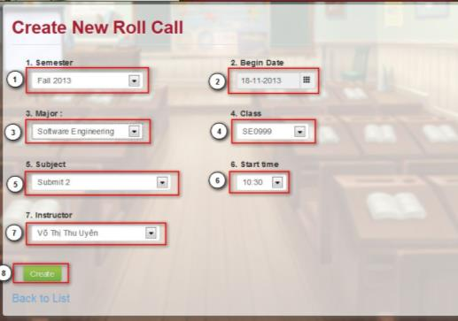

**Figure 21: Create Roll Call Page**

|  |  |
| --- | --- |
| **Step** | **Description** |
| 1 | Select the semester of roll call. |
| 2 | Select the start date of roll call. |
| 3 | Select the major of roll call. |
| 4 | Select the class of roll call. |
| 5 | Select the subject of roll call |
| 6 | Select the start time of roll call. |
| 7 | Select the instructor of roll call. |
| 8 | Click on button “Create” to create a roll call. |

**Table 6: Create Roll Call Step**

#### Change Roll Call Student List

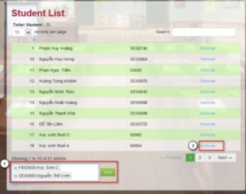

**Figure 22: Roll Call Student List Page**

|  |  |
| --- | --- |
| **Step** | **Description** |
| 1 | Click to remove student from roll call. |
| 2 | Type or select students to add to roll call. |

**Table 7: Change Student List Step**

#### Change Roll Call Schedule

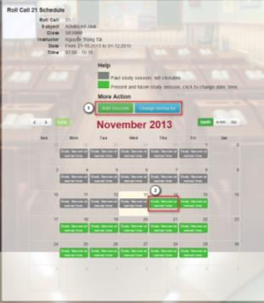

**Figure 23: Change Schedule Page**

|  |  |
| --- | --- |
| **Step** | **Description** |
| 1 | Click to add a session or change instructor of roll call. |
| 2 | Click to change session of roll call. |

**Table 8: Change Schedule Step**

### Instructor – Check Attendance (Mobile)

#### Login

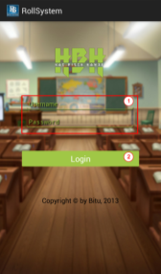

**Figure 24: Login Screen**

|  |  |
| --- | --- |
| **Step** | **Description** |
| 1 | Fill Username and Password  (Sample instructor account:  Username: phuonglhk. Password: 123456) |
| 2 | Click button Login |

**Table 9: Login Step**

#### View Roll Call List

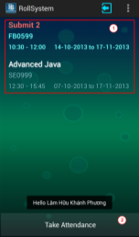

**Figure 25: Roll Call List Screen**

|  |  |
| --- | --- |
| **Step** | **Description** |
| 1 | View Roll Call list and make sure about the roll call that you want taking attendance |
| 2 | Click button Take Attendance |

**Table 10: View Roll Call List Step**

#### Take Attendance Auto

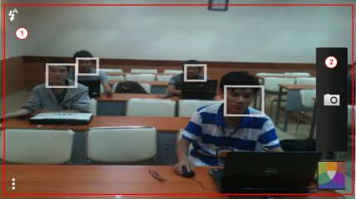

**Figure 26: Camera Screen**

|  |  |
| --- | --- |
| **Step** | **Description** |
| 1 | View camera screen and choose the best position and angle |
| 2 | Click button to capture image |

**Table 11: Check Attendance Step**

#### View Roll Call Detail

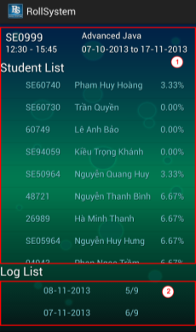

**Figure 27: Roll Call Detail Screen**

|  |  |
| --- | --- |
| **Step** | **Description** |
| 1 | View Roll Call info (class, subject, date, time, student list and log list) |
| 2 | Click one log you want to taking attendance manual |

**Table 12: View Roll Call Detail Step**

#### Take Attendance Manual

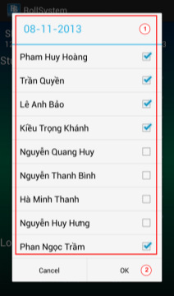

**Figure 28: Take Attendance Screen**

|  |  |
| --- | --- |
| **Step** | **Description** |
| 1 | View student list in roll call and check or uncheck any student. |
| 2 | Click button OK to taking attendance manual |

**Table 13: Take Attendance Manual Step**

### Instructor – Check Report

#### View Teaching Roll Call

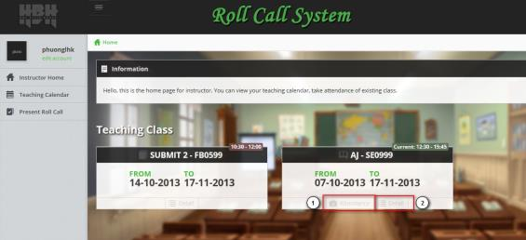

**Figure 29: Instructor Home Page**

|  |  |
| --- | --- |
| **Step** | **Description** |
| 1 | Click link “Attendance” to view and check attendance of teaching class |
| 2 | Click link “Detail” to view attendance detail of the roll call |

**Table 14: View Teaching Roll Call Step**

#### View Roll Call Report

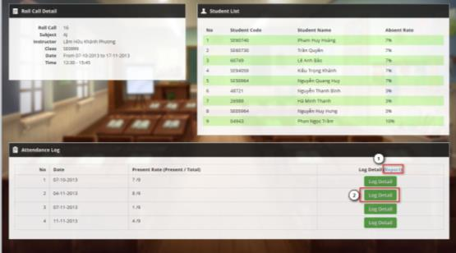

**Figure 30: Roll Call Detail Page**

|  |  |
| --- | --- |
| **Step** | **Description** |
| 1 | Click link “Report” to download the attendance report |
| 2 | Click link “Log Detail” to view the log detail of selected date |

**Table 15: View Roll Call Report Step**

#### Report Sample

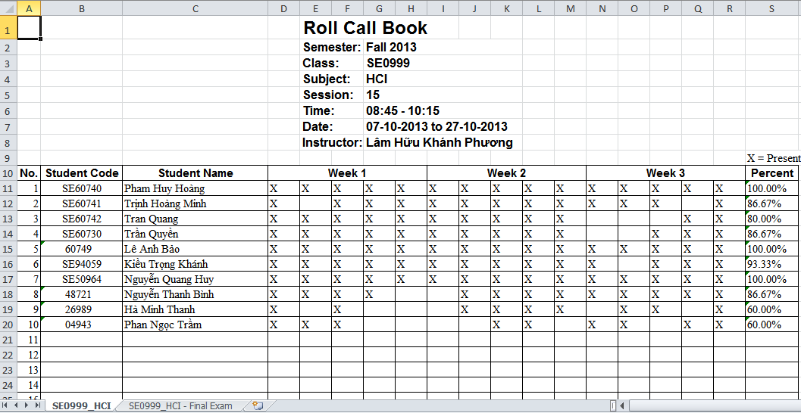

**Figure 31: Report - Sheet 1**

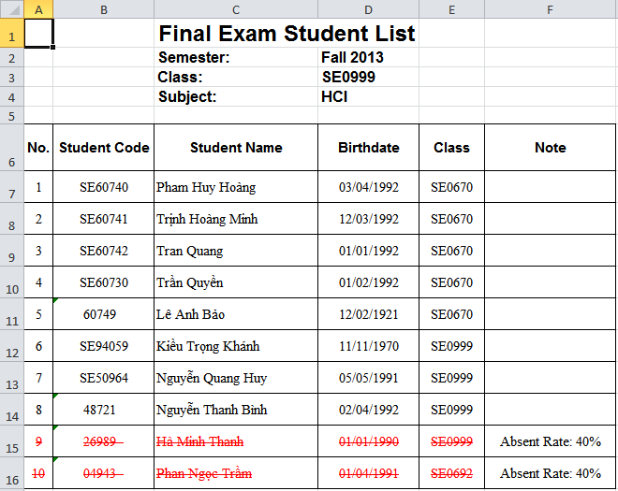

**Figure 32: Report - Sheet 2**

## User Notice

### Image Data Notice

* Each students must has at least 8 images as training images, for acceptable accuracy.
* The image should be clear without too much noise.
* Two eyes should be as the center.
* The face must look front, or tilt ~5-10 degree.
* Gray image is also okay

Example of good image data:



Sample data of a student (From 8-20 images), should contains:

* 70-80% of frontal face, with different brightness, facial expression....
* 20% of side face, with different brightness.

Example of a good sample data set:



Avoid using images like these:



### Position & Angle Notice

The below position and angle are recommend for best result.

For small class room

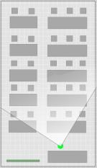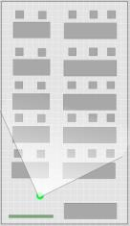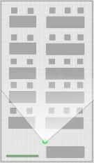

* According to test result, with class of 15-20 students, the number of required image is 4-6 images.
* With bigger class, the number of required image is 6-10 images.

### Other Notice

* The classroom should has good brightness.
* The student should look to front, look at the camera.

Example:

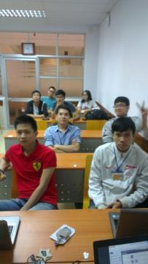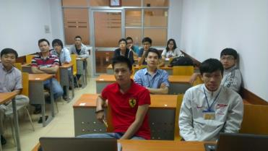

In some situation, the student on the front cover the face of back students, this lead to lower recognition rate.

Solution for better recognition rate:

* Take more images in different angles.
* Tell front student to lower their head.
* Use the “learning” modules.

